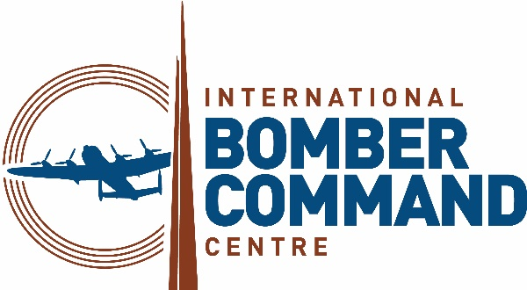
Gift Aid declaration – for past, present & future donations
LINCOLNSHIRE BOMBER COMMAND MEMORIAL

Please treat as Gift Aid donations all qualifying gifts of money made:
- today
- in the past 4 years in the future

Please tick all boxes you wish to apply.

I confirm I have paid or will pay an amount of Income Tax and/or Capital Gains Tax for each tax year (6 April to 5 April) that is at least equal to the amount of tax that all the charities or Community Amateur Sports Clubs (CASCs) that I donate to will reclaim on my gifts for that tax year.
I understand that other taxes such as VAT and Council Tax do not qualify.
I understand the charity will reclaim 25p of tax on every £1 that I give.
Donor’s details

Title……………………First name or initial(s)……………………………………………………… Surname……………………………………………………………………………

Address……………………………………………………………………………………………………………………………………………………………………………………………………………..

Postcode………………………………Telephone………………………………………………………… Email……………………………………………………………………………………

Signature………………………………………………………………………………………………………… Date……………………………………………………………………………………..

Please notify the charity or CASC if you:
- Want to cancel this declaration
- Change your name or home address
- No longer pay sufficient tax on your income and/or capital gains.
If you pay Income Tax at the higher or additional rate and want to receive the additional tax relief due to you, you must include all your Gift Aid donations on
your Self-Assessment tax return or ask HM Revenue and Customs to adjust your tax code.
Please send completed form and cheque (payable to IBCC) to: 13 Cherry Holt Road, Bourne, Lincolnshire, PE10 9LA

